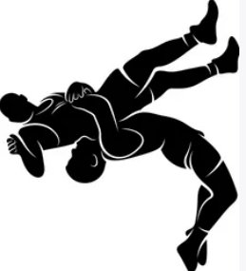Annandale Wrestling Club
Spring 2024
--------------------------------------------------------
The Annandale Wrestling Club (AWC) is a Grade 6-12 club for boys and girls that is located in Annandale, Virginia.
The focus of the AWC is to help all beginners and advanced wrestlers alike, achieve their wrestling goals. The room at Annandale HS has two full sized mats which can allow us to work with beginners and advanced during the same practice times. We will begin the spring season focusing on folkstyle (high school and college) for MAWA and NHSCAs, then once the calendar turns to the second week of April, we will focus primarily on Freestyle and Greco Roman (Olympic Styles). Practices will comprise of techniques, drilling and live wrestling. We plan to have a robust competition schedule to sharpen our skills and test our athletes in preparation for the VAWA state tournament in May.
Annandale HS is located at 4700 Medford Dr, Annandale Va 22003. Enter through Door 10 and head up the stairs to the aux gym, the wrestling room is on the left.
Practice Times: Mondays and Wednesdays 5:45-7:30pm. March 4th-May 15th
Cost: No cost for practices, USA card required (http://www.usawmembership.com/) Sign up for all three styles (Folk, Free and Greco)
Coaches: Joshua Damico, Allen Kokilananda, Guillermo Monterrosa, more to come.
If you have any questions, please email Joshua Damico @ annandalewrestlingclub@gmail.com

